Document Control
Document Name | Meeting Rooms Catering
Version No | 1.0
Classification | Internal
Date

Version Control
Ver No. | Author | Approved by | Approved Date | Description
1.0 | Jovil Nazareth |  |  | Initial Document
1.1 | Jovil Nazareth |  | 07/12/2022 | Multi-room Catering Request
2.0 | Jovil Nazareth |  | 15-01-2022 | Enhancements on Catering Request
2.1 | Jovil Nazareth |  | 24-02-2022 | Cancellation Policy for Rooms
2.2 | Kavya S |  |  | Categories for Catering, New Delivery time Workflow
2.3 | Kavya S |  | 12-03-2024 | Managing Catering Configurations on UI

MEETING ROOMS CATERING

Why build Meeting Rooms Catering:

Employees when planning meetings with clients, also need to plan for catering. Finding an affordable and delicious place to eat, while addressing dietary restrictions can be stressful for the organizer.

Serving high quality food helps showcase a business as professional and capable and hence, a lot of organizations offer well managed, in-house catering. In order to help the employee experience a hassle free booking experience, it is important to provide an option to book and avail this catering service.

Vision:
To provide a solution which addresses the following -
- As an employee, I want to request food / beverages for my meeting with clients so that a workplace team can pick up the request and arrange for food/beverages as per the request.
- As an admin / facility manager, I want to view the food / beverages requested in meetings and deliver them in time.
- As an admin / facility manager, I want to keep track of the order, its delivery, costs associated with it, housekeeping services requested, etc.

Solution:
Version - 1 of this document focuses on initial design of the catering UI, the acceptance criteria defined for the working of catering in meeting rooms and the architecture for menu

Version - 1.1 of this document focuses on multi-room catering requests. Catering can be requested either from Outlook Add-in or from Workinsync UI. Here the scope is limited to booking of catering services from outlook add-in. This version does not include editing of the catering request

Version - 2 of this document focuses on catering dashboard, multiple enhancements surrounding catering and the architecture of its menu
- Separation of catering for office and meeting rooms
- Filter of data on catering while booking
- Order delivery time
- Order cleaning time / Housekeeping
- Special request to the catering provider
- Cutoffs for each menu item (by when they can be ordered and during what slots they are available)

Acceptance Criteria (V-1):

- Option to request catering should be configurable
  - ENABLE_MEETING_CATERING: True → Enables catering request for meeting rooms
  - ENABLE_MEETING_CATERING: False → Disables catering request for meeting rooms
- An office can have multiple cafeterias and each cafeteria can have multiple menus. Similarly, multiple offices can have the same cafeteria.
- Multiple offices with same cafeteria (Not yet built)

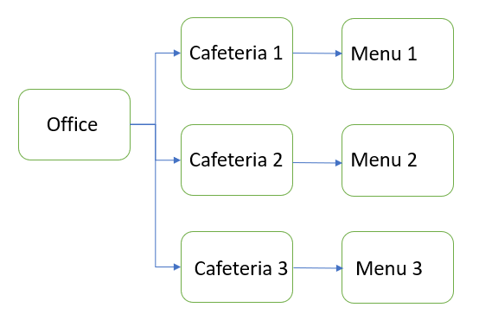

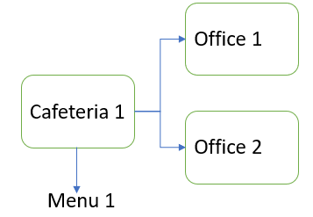

- Meeting Room, Office and Cafeteria:
  - A room is associated with an office, and thereby can have multiple cafeterias associated with it
  - By default, all the cafeterias present in that office should be associated with the room
  - Admin can choose to remove a cafeteria for a room which would in turn remove that specific menu for the room
  - More than 1 menu can be mapped to the room
- Menu → The menu in itself should be configurable with “n” number of rows to support various food and beverages
  - In Version 1, addition of items in the menu will be supported through Backend
  - Menu would have the following columns -
    - Name: Name of the food item
    - Price: Price of the food item
    - Type of Food: Veg / Non-Veg / Vegan
- Price:
  - Denomination used to determine price can be set at the office level (but it was built for item level)
  - All acceptable forms of denomination across the world should be supported by the system
  - By default, denomination should be set to USD (not built yet)
    - By default the denomination is INR
- Showing of Price / Cost: (Not yet built)
  - Showing of cost of the food item should be configurable – i.e., if an office requests cost to not be visible, it would not be visible for the end user
  - Name of the property: May not go with property. Solution would consist of FE not showing price when price is set to zero or negative value
  - Note: This is to be supported at office level in Version 1
- End user – email ID
  - Every office should have a set of email IDs which receive an email notification whenever a user requests for catering. (Version 1)
Room - wise email IDs to be built in Version 2
  - “Sending of an email itself should be configurable” - i.e., sending email can be disabled. Property name:
  - The list of email IDs receiving this notification should support “n” number of email - IDs
- This data should be visible to the admin in a separate UI and report (will be explained below)

Organizer UI (V-1):

- Users should be able to request catering along with the meeting room booking request if the property is enabled.
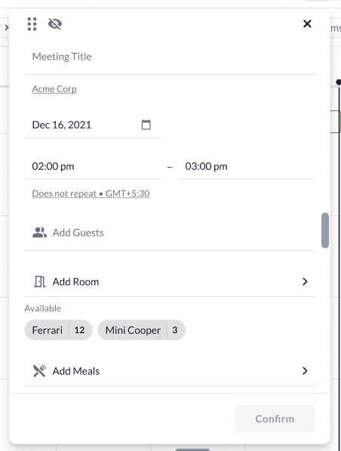
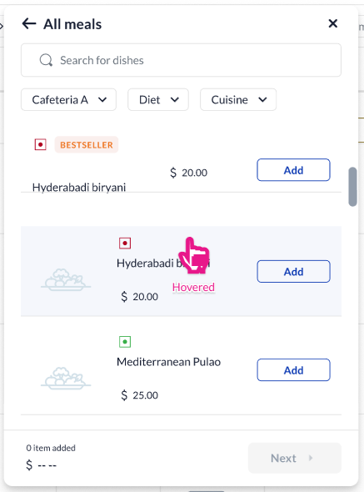
- Users should have the option to select different dishes in the menu simultaneously
- Users should be able to select higher quantities of the same food
- This selected quantity should be totaled in the bottom of the meal selection form so that the user can view the total items selected and the cost of the item

Multi-room Catering Request:

This section covers the multiple room catering requested

Use Case 1 (V-1.1):
User creates a multi-room / multi-catering booking using Outlook Add-in

- The user selects multiple rooms and different catering request for each of those rooms
- These meal requests need to be displayed on meeting room web
- Room’s Calendar:
  - The room should show the booking and meal specific to that room only. I.e., if there are multiple catering booked, only the one relevant to the specific room should be visible
  - Room should not show the meals that are not relevant to that room
  - Room should not show “meals requested” if there is no catering enabled for that room
- User’s Calendar:
  - The user’s calendar should show all the rooms booked and the catering requested for each of those rooms
  - The summary view would show the name of the room and the number of items requested in each of the rooms
  - The detailed view shows all the rooms, the meal name, meal type, cost if it exists, quantity of each meal and which room it was ordered for

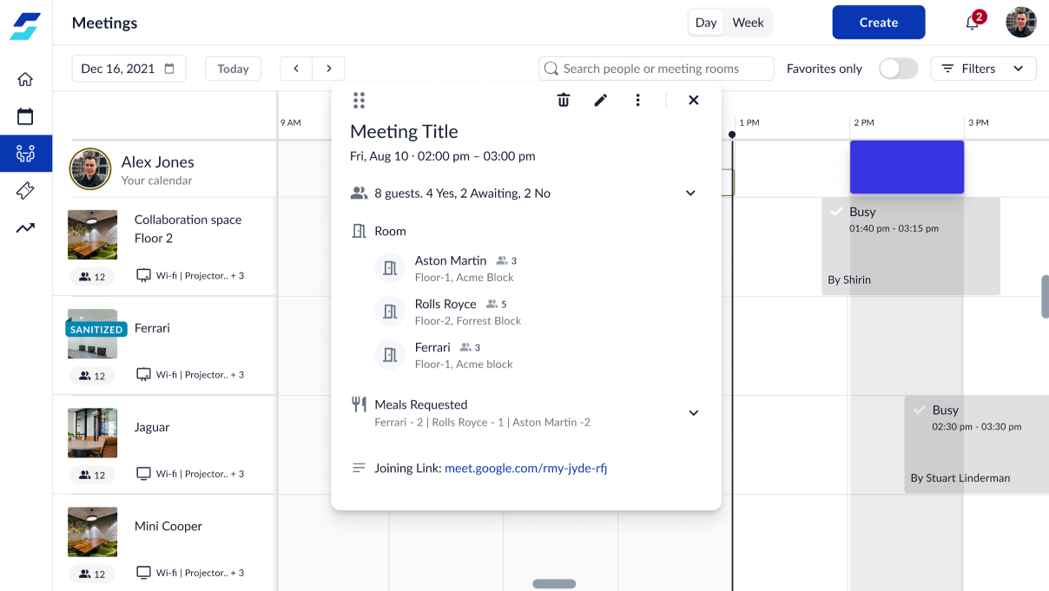
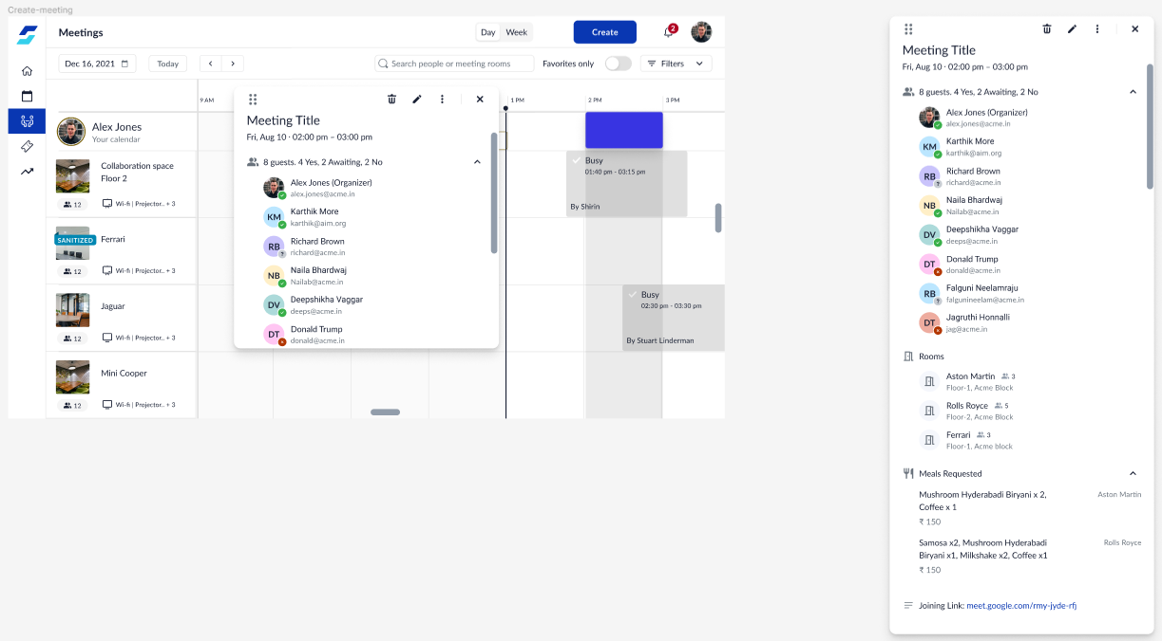

Use Case 2 (V-3): (Not yet built)
User creates a multi-room / multi-catering booking using workinsync

Use Case 3 (V-3):
User wants to edit the meeting on workinsync

- User can only edit the first room that appears
- This constraint would be removed as and when we build this feature

Enhancements on Catering Request (V-2):

This section consists of multiple enhancements around catering.

Office and Room Catering:

At present, the catering for the office and room is the same. This needs to be separated to support the below mentioned cases
- Catering setup is only for room
- Catering setup is only for office
- Catering setup is for both room and office

Filters on Catering Booking:

The menu for a particular room may be vast. The user would be able to extract relevant data by applying filters for booking a catering request -
- Filters to be applied:
  - Cafeteria
  - Type of Food Item - Veg / Non-veg / Vegan
  - Menu (may introduce V-3)
- Initial data load: Would consist of all the food items from all the cafeterias (and menus) that the room is mapped with
- Cafeteria filter:
  - All the cafeterias associated with the meeting room
  - Multi-select filter
- Type of Food item:
  - Multi-select filter
  - It would search across all the cafeterias and menus that the room is mapped to

Order Delivery Time: (Old Flow)

This refers to the delivery time of the catering order.

Figma: https://www.figma.com/file/RyznriqjlcWXiJe9jlgHRL/Meeting-rooms-V2?node-id=1575%3A142424&t=s8g4wrtpLwHEtmFf-4

Solution:

- Within the selected time of the meeting, the user can choose which items to be delivered when
- UI changes:
  - When user selects the option to “Add Catering Request”, it leads to a screen which shows the option to select the number of deliveries and time of delivery for every order
  - There’s a CTA to select the food items which leads to the screen with all the menu items
  - Once the user selects the items and clicks on “Next”,
    - the items are displayed on the modal, with an option to add more items if needed
    - Another CTA provides the option to “New Delivery Slot”
  - Bottom of the modal no longer displays the total cost of items + number of items, only the number of items added i.e
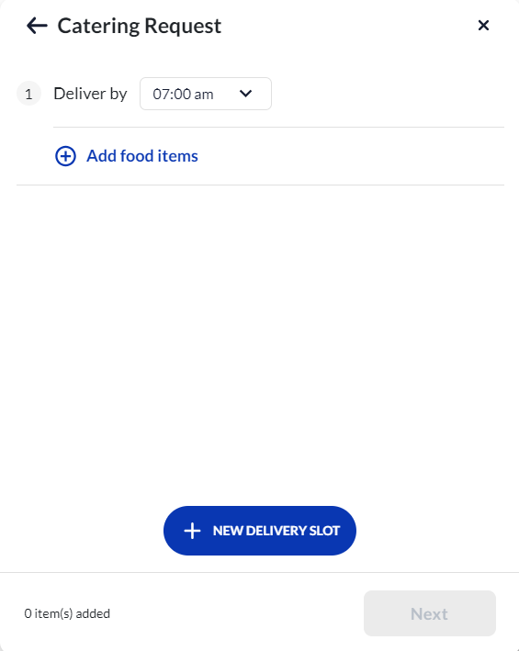e The “Next” CTA takes the user to a set of dynamic fields if any
  - The “Confirm Order” CTA stores the information relevant to the catering order
- Once the user creates the meeting, based on time of delivery and cafeteria, the order gets created with relevant order IDs:
  - The order ID is an unique indicator for each order.
  - A order ID would be generated for each of the following scenarios -
    - Catering order is placed from meeting rooms
    - Catering order is placed from visitor management (Not yet built)
  - Each meeting or event would have either one or multiple order IDs based on cafeteria and delivery
  - Order to be delivered at the same time: A single meeting can have food requests from one or more cafeterias for the same delivery time. Each of the cafeteria request, would form as a new order
  - Different delivery time: A meeting can have food requests that are to be delivered at different times. Each of the request would then form a different order ID
  - Multiple Room: Each room would have a different order ID honoring the above 2 points
- The meeting has its own ID with 1 or more order IDs associated with it
- For more information on Order ID and Meeting ID, refer to Catering Dashboard PRD

Order Delivery Time: (New Flow)

Problem Statement:In the existing workflow, whether creating or editing an event, changing the delivery time refreshes and removes any added catering items. This process disrupts the user experience, as users have to reselect catering items each time they adjust the delivery time. This is particularly inconvenient when the time change is minor and does not affect the availability of the selected items.
Solution Statement: When a user is creating or modifying an event, and they alter the delivery time, it's important to ensure that the selected catering items remain in their order. The system should automatically verify which items are still available for the newly chosen delivery time. Any unavailable items should be identified, enabling the user to easily comprehend the changes in catering item availability resulting from the updated delivery time selection.
Acceptance Criteria:
- This new flow of changing the delivery time replaces the current delivery time flow → wherein if a catering order has items added to it (in create or edit state of a meeting+catering booking) changing of delivery time will remove the catering items in that delivery time
- Not based on configuration, default flow
- Should work on WIS Web and Outlook Addin, for all Meeting Rooms setups (Integrated, Native)
- A user can change the delivery time an infinite number of times
- Meeting ID and Order ID logic still stays true to this flowi.e
    - Each meeting or event would have either one or multiple order IDs based on cafeteria and delivery
    - Orders to be delivered at the same time: A single meeting can have food requests from one or more cafeterias for the same delivery time. Each of the cafeteria request, would form as a new order
    - Different delivery time: A meeting can have food requests that are to be delivered at different times. Each of the request would then form a different order ID
    - Multiple Room: Each room would have a different order ID honoring the above 2 points
    - The meeting has its own ID with 1 or more order IDs associated with it
Figma:
Create State
Use Case 1.0 I am creating a meeting booking with catering from 12-1pm on WIS web, and I choose different delivery times and add catering items so that I can define what I want to be delivered at what time, on web and Outlook Addin
- I choose 1215pm as the delivery time, and add my catering items (5 items)
- I add another delivery time (1230pm) and add catering items (5 items)
- There will be a tooltip next the “Deliver by” that states the following:
  - “Changing of delivery time may cause change in availability of catering items for selected delivery time.”
- I go back to 1215 delivery time and change the delivery time to 1245, what should happen:
  - Instead of clearing the 5 items already selected, when the user tries to change the delivery time, we will
    - Compare the newly selected time (1245) with current (5) items to ensure they are still available at that time.
    - If all items are still available, the # of catering items will be retained and they will be displayed in the preview below the delivery time as usual
    - If there are items that are no longer available: They should be removed from the # of catering items added for that delivery time
    - Unavailable items would be displayed first, under “Unavailable” and their correct availability written next to the catering item
    - The user can then go and select more catering items they wish to add to that delivery time
Use Case 1.1 I am creating a meeting booking with catering from 12-1pm on WIS web, and I delete delivery times to reduce deliveries du
- In the create state, if the user deletes a delivery time, that delivery time is removed from the UI along with the associated catering items.
  - Applies for web and Outlook Addin
Edit State
Use Case 1.2 I am editing an existing meeting booking with catering and I change only the delivery time to accommodate the change in the meeting plan
- When delivery time is changed in EDIT state of a meeting booking with catering, the following should occur:
  - After changing the delivery time, use case 1.0 would be followed before the user saves the meeting booking
  - After saving the meeting with new delivery time:
    - Order ID/order of changed delivery time should not get canceled/be marked canceled, but the time should just be updated
    - The Order ID should retain the status it was in before delivery time was changed
      - Ex - If order #1234 was created and has default status of ‘Requested’, the user then edits the catering order and changes delivery time → status should remain Requested, only time will be updated.
    - The new time would get update for the previous delivery time →
      - When time was changed from 1215 pm to 1230 pm, on the catering dashboard:
        - The order would get updated for its TIME and catering items, not any other detail such as order id, meeting id, status, location, or organiser. (cost center can be changed at any time)
Use Case 1.3 I am editing an existing meeting booking with catering and I am changing the delivery time for a meeting with cut-offs in place
- In current catering workflow there are cut-off policies in place with regards to participants
- If delivery time is changed when the cutoffs are in place, the following would happen:
  - On Web:
    - If the meeting is past the cut-off time where the catering order cannot be modified, when the organizer clicks on “Delete” or “Edit” meeting option → the organizer sees a pop-up “This meeting contains catering request, which cannot be modified”
  - On Outlook:
    - Any change in catering request, for a booking within cutoff, will result in that Order ID being cancelled with the status of Canceled Short Notice

Categories for Catering List Items
Problem Statement:
The current catering menu displays items in a random order, making it difficult for customers to browse and select items efficiently, particularly when they are looking for options specific to different meal timings or types of food. This unorganized presentation can lead to a frustrating user experience, longer decision times, and potentially decreased sales due to the inconvenience.
Solution Statement:
Implement a feature that introduces collapsible categories within the catering menu. These category names will be configurable, allowing catering setup to have logical groups that facilitate easier and quicker browsing based on client requirements.
Acceptance Criteria:
- SE team to be able to add these categories when setting up the catering menu for a cafeteria
  - The SE team should be able to create and update categories through the same API currently being used to update catering menu
  - This field/feature should also be added to the frappe tool for meal configuration which is yet to be developed
- Structure of catering menu setup should be: cafeteria > menu > > menu items with categories, cut off time and preparation time
  - Cutoffs and preparation times will continue to apply to each single menu item, NOT categories
  - Categories would be mapped to each item
- Allow order to be defined for categories (should not follow A-Z order or be randon order)
- It should be possible to rename a category without losing the items assigned to it.
- If a category is removed, then all the items under that would not belong to a category and display outside of categories, items SHOULD NOT get removed
- These ‘categories’ can be named as anything → accept both alphabets, numbers and special characters (usually associated with localized languages)
  - Ex - ‘Breakfast’, ‘Category 1’, ‘Category 2’, ‘Château Cheeses’
- Each category section should be collapsible and expandable
  - Upon selecting (expanding) a category, the user should see all items listed under that category, in alphabetical order
- In the search bar of the menu items, users should be able to search for menu items and categories → results should take both into consideration

Figma:
Use Case 1.0 As a user I want to make a meeting booking with catering on WIS web/Outlook Add-in, so that I can order Breakfast for my meeting that is scheduled from 9 AM - 11 AM, for the next day (24 hrs later)
- Setup of catering:
  - Categories + Items:
    - Breakfast: Poha (8AM to 11 AM), Bread Jam (8AM to 11 AM), Coffee (8AM to 11 AM)
    - Dinner: Biriyani (12 PM- 2PM), Lunch Combo Roti + Curry (12 PM- 2PM)
    - Snacks: Assorted Chaats (5PM - 6PM), Popcorn (5PM - 6PM)
    - prep time: 1 day
    - Order of categories is: Breakfast, Snacks, Dinner
- User will click on Add food items, this is when the categories would be visible
    - Upon opening the menu, all categories would be collapsed, with order of Categories as configured (Bf, Snacks, Dinner)
    - If there are items that are unavailable in certain categories, catering items would be displayed in the category but with the grey box of the availability i.e Available from 2 PM today
  - The user can add the items the require from Breakfast category and confirm
  - Adding a new delivery slot should work as per the workflow of delivery time mentioned in https://moveinsync.atlassian.net/browse/PB-36345 and adding delivery instructions should work as per the usual flow
  - User will place order and complete the meeting booking form
- On the catering dashboard, the categories would be consumed and displayed as suc : Figma

Use Case 1.1 As a user I want to edit a meeting booking with catering on WIS web/Outlook Add-in so that I can change items for my meeting that was scheduled from 9 AM - 11 AM but I changed it to 2pm-3pm
- No changes to edit logic based on categories as there are with other elements in catering such as delivery time, date/time etc. Follow same logic in terms of displaying categories as Use Case 1.0
- Follow the edit flow in place that is set for catering, no specific edit flow w.r.t to categories
Use Case 1.2 As a user I want to cancel a meeting booking with catering on WIS web/Outlook Add-in due to change in plans
- Cancel flows of catering to remain the same, there are no cut-offs/cancellation policies w.r.t categories.

Cut-offs for Catering Booking:

Three kinds of cut-offs for catering booking

- Restricting the catering order as a whole
- Restricting the order time of specific items in the menu
Eg: lunch can only be ordered during lunch time
- Capability to specify for each menu item when (time) is the latest that this menu item can be ordered (e.g. the menu item breakfast has to be ordered latest the previous day at 17.00)

Restricting the catering order as a whole:
- The organization may have policies to restrict the catering order so that last minute orders are not placed
  - The cutoff can be “n” minutes before the order start time
  - Property to be configured at an office level
  - By default the cutoff should be set at 60 mins for all clients
- This would gray out the option to select catering in the booking form of meeting rooms
- If user clicks on the catering option, a toast message will appear “Order can be placed ‘n’ minutes before the meeting”

Restricting the order time of specific items in the menu (time range):
- The admin / facility manager / catering provider would be able to specify the latest time range that specific items in the menu can be ordered
- This time range for the items should be in between that of the time range specified for the menu
- The “Add” button would be replaced by a text box with content “Available between 1pm to 4pm”
- Time input would be the time of the meeting that the user is trying to create
Capability to specify for each menu item when (time) is the latest that this menu item can be ordered:
- Certain items in the menu can only be ordered “n” number of hours before the meeting
  - “N” can be minutes / hours
  - N → configurable value specific to the item
  - This is set at the item level
- Time input would be the time of the meeting that the user is trying to create
- The “Add” button would be replaced by a text box with content “Available at “n” tomorrow”
  - Here the “n” specifies time in am or pm
- In case both cut-offs, (time range cutoff and ordering cutoff), both are applicable to this item, then show the ordering cut-off message
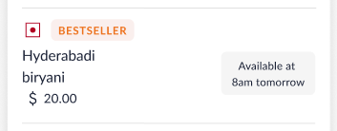

Old Flow: Edit of Meeting With Catering:
Acceptance Criteria:
- Should work for catering flow on WIS web, Outlook web and Outlook app (on both windows and Mac)
- Should handle time zones (test with different time zones)
Tasks:
- Edit of meeting with catering
Edit of Meeting With Catering:
- There are 2 types of meetings -
  - With catering request
  - Without catering request
  - I have for you here the meeting with the catering request section.
  - Meeting without catering requests is covered in the meeting rooms PRD.
- Edit of meeting with catering on web: If the user clicks on the option to edit the meeting, and it contains catering, a pop-up would appear informing the user - “This meeting consists of catering request(s). Modifying date, time, room may require catering to be selected again and the previous order would be marked canceled”
  - If user clicks on “Proceed” → user reaches the booking form in edit state and catering order changes based on below defined use cases
  - If user clicks on “Cancel” → user returns to the meeting form without any modification
- Edit of meeting with catering on add-in: No pop-up message
Use Case 1.0: Edit of Title, Description and Special Requests on WIS Web, Outlook Web and Outlook App
- Behaviors that will not modify the catering i.e revert back to requested/any other status other than what is the current status
  - Change in title of the meeting
  - Change in description of the meeting
  - Change in special request of the meeting
  - Change in delivery instructions of the catering order
Use Case 1.1: Edit of Room, Date, or Time
- Room is changed -
  - On the meeting booking card, the existing catering order would be removed. In case the user does not save it and goes back to its original state, no changes would happen on the order.
  - Changing of room would mark the respective catering orders (respective order IDs) as “Canceled”
  - If the organizer selects a new room, a new set of catering orders would be created against the same Meeting ID, with new Order IDs for that meeting whose state would be “Requested”
- Date or Time is changed -
  - Changing of date or time would mark the respective catering orders (respective order IDs) as “Canceled”
  - If the organizer selects a new date or time, a new set of catering orders would be created against the same Meeting ID, with new Order IDs for that meeting whose state would be “Requested”
Use Case 1.2: Edit of Participant list (add/removal of participants) (Not yet Built)
- Change in participant list (add/remove of participants)
  - If the user’s edit time of add/remove participants is before the order cut-off times (defined below), there would be no change to catering order status
  - If the user’s edit time falls beyond the cut-off time then the catering order would be “canceled - short notice”
  - Cut-off times based on # of participants (for e.g., only):
    - 7 days (Large events >50)
72 hours prior (Medium event 20-50)
48 hours prior (20-10 pax)
24 hours prior (0-10 pax)
  - Behaviors of what should happen using an example
    - Ex - User created a meeting booking for Oct 20th 8 AM, with 20 people invited. They can add/remove guests up till date of Oct 18th 8 AM → where there would be no change to the catering order status, only the number of guests would change in the detailed catering order view
    - After Oct 18th 8 AM any modifications to the participant list would result in the catering order getting cancelled with the status ‘cancelled - short notice’
Use Case 1.3: Edit of Delivery Time
- Changing the delivery time of an existing order →
  - The previous selected items would be removed
    - If there was an order for 6:30 AM and that exact order is changed to 6:45 AM, then the catering items associated with 6:30 am would be removed and the user would need to select again what catering items they want for 6:45am
  - Upon confirming the meeting booking, the previous catering order i.e 6:30 AM would be canceled & marked “cancelled” on catering dashboard
  - The new order i.e 6:45 would be created with the new delivery time and new order ID with previously available meeting ID
- Adding a new delivery time →
  - Addition of a new order delivery time to the meeting (without removing the previous order) →
    - a new order would be created with the new delivery time
    - Meeting ID would remain the same
  - Existing order status should remain as it is, the new delivery time will be added to dashboard
- Addition of a new order delivery time to the meeting by removing the previous order →
  - The previous order which is removed would be canceled and marked “cancelled” on catering dashboard and the new order would be added to the dashboard with status “requested”
- In case of multiple rooms and multiple orders → the above use cases would hold valid
Use Case 1.4: Edit of Catering Items (Adding/Removing catering items)
- For an existing catering order (regardless of the status), when catering items are removed or added, the previous order for that time slot should be canceled and a new order should be made for the new items keeping the same meeting ID but new order ID

Flow chart: https://whimsical.com/meeting-rooms-catering-edit-workflow-YRhgKQXq7Ve4UTj4m9EWwK
- In case of multiple rooms and multiple orders → the above use cases would hold valid

New Flow: Edit of Meeting With Catering:
Acceptance Criteria:
- Should work for catering flow on WIS web (G Suite + Outlook + Native), Outlook web and Outlook app (windows and ios)
- Should handle time zones (test with different time zones)
- Meeting with catering on WIS web cannot be edited if current time > start time of meeting
- Meeting with catering on Outlook Add-in: Meeting can be edited, but catering order would remain as is, with no modifications if current time > delivery time of the meeting
- Audit should be captured for any modifications in the order
Edit of Meeting With Catering:
- There are 2 types of meetings -
  - With catering request
  - Without catering request
  - This doc describes the meeting with the catering request section; Meeting without catering requests is covered in the meeting rooms PRD.
- Edit of meeting with catering on web: If the user clicks on the option to edit the meeting, and it contains catering, a pop-up would appear informing the user - “This meeting consists of catering request(s). Changing room may require catering to be selected again and the previous order would be marked canceled”
  - If user clicks on “Proceed” → user reaches the booking form in edit state and catering order changes based on below defined use cases
  - If user clicks on “Cancel” → user returns to the meeting form without any modification
- Edit of meeting with catering on add-in: No pop-up message
- The edit flow is valid on WIS web (integrated and native setups), Outlook Web and Outlook App (on the add-in)
- Solution overview: In most cases, the edit of the meeting (which contains catering order) would not modify the status of the order. Only in specific use cases the order would be marked as canceled and a new order would be created
- Any update in the order’s status or the order itself should be published to the reporting section as well

The use cases have been divided into multiple parts in order to cover the extensiveness of the flow
Use Case 1.0: Straightforward use cases that do not modify the status of the catering order
- Behaviors that will not modify the catering i.e revert back to ‘Requested / Accepted’
  - Change in title of the meeting
  - Change in description of the meeting
  - Change in special request of the meeting
  - Change in delivery instructions of the catering order (i.e., dynamic fields)
  - Changes in cost center
- Any modification in the above would keep the status of the catering order as is

Use Case 1.1: Edit of meeting that contains catering and change in delivery time
- If the organizer changes the delivery time of the order, the catering form would not be reset as described in Order Delivery Time: (New Flow)
- If the organizer saves the order with the modified delivery time, then the previous catering order would not be marked ‘Canceled’, and continues to stay in the ‘Requested / Accepted’ state
- No changes in Order ID or Meeting ID and the original IDs remain
Use Case 1.2: Change in participants of the meeting
- If the organizer change the number of participants in the meeting, this would affect the status of the order if:
  - Current time (of editing) is before the cut-offs defined based on the flow described under “Participants and their cut-off” – order’s status remains unchanged
  - Current time (of editing) is post the cut-offs defined based on the flow described under “Participants and their cut-off” – order’s status changes to ‘Canceled - Short Notice’
- No changes in Order ID or Meeting ID
Use Case 1.3: Change in number of items in the catering order
- If the organizer changes the number of items in the catering order:
  - The order gets updated with the change in items, but no change in order’s status
- No changes in Order ID or Meeting ID
Use Case 1.4: Change in date, start time and end time of the meeting that contains the catering order
- If the organizer changes the date, start time or end time of the meeting which contains the catering order and the add-in is open:
  - The delivery time of all the catering orders in the meeting changes to the start time of the meeting if the duration of meeting is completely different from the original duration (i.e., 12pm-1pm changes to 2pm-3pm)
  - If duration of the meeting is slightly different than the original duration of the meeting, only the delivery time which does not fall under the new duration changes to start time of the meeting. The other delivery time remains the same.
For e.g., original duration: 12pm-1pm and delivery times: 12:15 and 12:45
New duration: 12:15pm-1:30pm, delivery times: 12:15 & 12:45 – no change
New duration: 12:30pm - 1:30pm, delivery times: 12:30 & 12:45
  - The items in the order will be rechecked for their availability based on the flow Order Delivery Time: (New Flow)
- The cut-off for participants and availability of the meals would be applicable
- No changes in Order ID or Meeting ID
Use Case 1.5: Change / Addition in room of the meeting that contains the catering order
- If the organizer adds an additional room to the meeting and chooses catering with it:
  - Then the original order (order IDs) stays as is without any modifications in its status
  - A new order ID is created for the new room (with previous meeting ID) with ‘Requested / Accepted’ status
- If the organizer changes the room which previously contained a catering order and chooses food items for the new room:
  - Then the catering items of the previous should be cleared from the form
  - The previous orders should be ‘Canceled’
  - New order would be created against the new room with ‘Requested / Accepted’ status
  - Meeting ID should remain the same
Use Case 1.6: Edit of meeting that contains catering once the order has been marked as delivered
- In case the catering order was in ‘Rejected / Delivered’ state, then the order would be marked as ‘Requested / Accepted’ state

Hide catering option if menu is not assigned to a room
Problem Statement:
- If menu is not assigned to a room, this is equivalent to catering not being present for that room.
- At present, the user still sees the catering option and then sees that no item is present for booking which hinders the experience of the user.

Solution:
- Hide “catering booking option” if no menu is present for the room
- If a menu is not assigned to a room, then:
- Web → hide the “Add Catering Request” option
- Outlook add-in → hide the catering symbol from where catering booking is created - to be decided after tech discussion
- App / Kiosk → not applicable as catering cannot be booked from here
- Applicable for integrated (outlook + google) and native rooms

Catering Dashboard:

Catering Dashboard PRD

Dynamic Fields:

Dynamic fields are fields in a database that have different data types or values for different records. They are used to store data that vary from one record to another and that does not fit neatly into a predetermined data structure. They can be helpful to store data in a flexible format that can adapt to changing needs

Different types of dynamic fields include:

(Text in bold is part of Jan 2023 sprint’s scope)

- Text fields: Text fields can be used to store text strings of varying lengths. They might be used to store strings of varying lengths like short descriptions (comments), longer descriptions (notes, etc)
- Boolean fields: These fields can be used to store True/False values. They might be used to store things like flags or indicators
- Numeric fields: These fields can be used to store numbers including integers, decimals, and floating point values. They might be used to store things like prices, quantities or ratings
- Data fields: These fields can be used to store dates and times. They might be used to store things like event dates, timestamps, etc
- Geospatial fields: These fields can be used to store geographical coordinates and other geospatial data. They might be used to store things like addresses, locations or maps
- Object fields: These are for storing complex data like arrays or nested objects. They might be used to store things like lists, trees or graphs
- Binary fields: Fields to store binary data such as images, audio or video. They might be used to store things like attachments, media files, digital documents etc

Figma: https://www.figma.com/file/RyznriqjlcWXiJe9jlgHRL/Meeting-rooms-V2?node-id=1642%3A202251&t=pRqMPQ1uVwPtJeoS-1

Parameters to define dynamic fields:

A user can define a dynamic field based on the following parameters:
- Label: The header of the dynamic field
  - For instance, dynamic field for entering the information of the person who is creating the catering order would have label as “Organizer’s Contact Information”
- Data structure (or Subtype): The structure of the data inside the dynamic field can be defined by the user.
  - For instance, if one is storing customer information, they might want to create separate fields for Customer’s name, address and phone number
  - Or if one is storing a date range, they may want to create separate fields for start date and end date
- Default value: The value that would be present by default in the field can be defined by the user creating the dynamic field
- Placeholder text: The user creating the data field may want to define a placeholder text to provide the user a format for entering the data
- Other things to consider:
  - Data type: To consider the appropriate data type for each field, based on the type of data being stored. E.g., a numeric field for storing numbers, a text field for storing strings
  - Data validation: Rules to ensure that only valid data is entered into the fields. E.g., only numbers are entered into numeric fields, validate that a date field contains a valid date, URL consists of a valid type of URL link, etc
  - Min and max value: Certain numeric fields may have constraints like, minimum and maximum value that can be entered
  - Performance:
  - Maintainability: The option to add and remove fields as the data changes should be simple and scalable

Working of these dynamic fields:

- The dynamic fields will be setup by the admin (out of scope) (Not yet built)
- These fields would be displayed to the employee on both Outlook add-in and Workinsync
- The output of these fields would be displayed to -
  - Employee as the summary of their order in the meeting room (out of scope) (Not yet built)
  - Employee in the email triggered after successful placement of the catering request
  - In the special instructions section of the catering order for all the roles who can access the catering dashboard

Cancellation Policy for Catering:

Note: This cancellation policy is only applicable to meetings with catering requests. Meetings that do not have catering associated with them would not have any implication

Problem Statement: If a meeting with a catering request is canceled at the ‘nth minute, a lot of resources (food, beverages, etc) associated with that request go to waste. This would also have monetary implications.

Solution:
To build a cancellation policy around meeting with catering requests so as to avoid wastage of resources

- The cancellation policy checks for 2 sets of data:
  - Time of request of cancelation vs the start time of the meeting
  - Number of people in the meeting
- Based on the number of people in the meeting, the cut-off prior to which the meeting can be canceled would vary
For e.g.:
7 days (Large events >50)
72 hours prior (Medium event 20-50)
48 hours prior (20-10 pax)
24 hours prior (0-10 pax)
- Admin should have an option to set different cut off time based on different pax range

Use Case 1.0: User tries to cancel / edit a meeting with catering request from Workinsync’s meeting room system
- Based on number of pax in the meeting, if
Time of cancelation request - start time of the meeting = (less than cut-off time set)
Meeting would be canceled, but catering for that meeting would change to a different status
- Catering order: The order status would change to “Canceled - Short Notice” to reflect that the order was canceled at the last minute
- If the meeting is past the cut-off time where the catering order cannot be modified, when the organizer clicks on “Delete” or “Edit” meeting option → the organizer sees a pop-up “This meeting contains catering request, which cannot be modified”
- Edit flow: The organizer can modify the meeting, but cannot modify the catering request
  - Modifying catering: Catering is grayed out and cannot be modified
  - Date and Time: Date and time of the meeting can be changed
  - Changing of room: Changing room would remove the catering request.
    - As catering cannot be modified, changing of room would mark the respective catering orders (respective order IDs) as “Canceled - Short Notice”
    - If the organizer selects a new room, a new set of catering orders would be created against the same Meeting ID, with new Order IDs for that meeting
  - Changing Title: No effect on the catering order
  - Adding / Removing guests: No effect on the catering order
  - Description and Special request: No effect on the catering order
- Cancel flow: If the organizer cancels the meeting, the meeting would be removed from the organizer’s and room’s calendar
- An email would be sent, similar to the catering request email with following changes:
  - Subject: Catering Request not canceled for Meeting ID: xxxx
  - Body of the email: The catering order associated with Meeting ID XXXX could not be canceled as it was past the time for order cancellation. The order details are as below:
{Same body as catering request email}
  - Who all would receive: Organizer and set of configured users for that office

- What happens if the organizer reduces the number of guests in the meeting - saves it; comes back later and modifies it, will a different cut-off be applied? - Allow them to do it

Use Case 1.1: User tries to cancel a meeting with catering request from Outlook / Google where the cut-off for the catering order has passed
- The meeting would be canceled and removed from the user’s and room’s calendar
- The catering order’s status would change to “Canceled - Short Notice” to reflect that the order was canceled at the last minute
- An email would be sent, similar to the catering request email with following changes:
  - Subject: Catering Request not canceled for Meeting ID: xxxx
  - Body of the email: The catering order associated with Meeting ID XXXX could not be canceled as it was past the time for order cancellation. The order details are as below:
{Same body as catering request email}
  - Who all would receive: Organizer and set of configured users for that office
- All other flows would stay valid as described in Use Case 1.1

Use Case 1.3: User tries to book a meeting with catering whose cancellation is already passed
- The organizer would be allowed to book a meeting with catering even if cancelation cut-off has passed
- The organizer would not be able to cancel the order and cancelation cut-off policies would be applicable

Catering Configurations Management
Figma: https://www.figma.com/file/WeJg9vdrUcWEPjcIWLr3uz/Catering-Dashboard?type=design&node-id=3945-214245&mode=design&t=ruBz2O4d2IwAATqm-11

Managing Cafeterias on Manage Premise page

Setting up Cafeterias for an Office

Acceptance Criteria:
- The old way of adding a cafeteria would be nullified and the below way to add a cafeteria would be followed
- Would not work on WIS+ETS sites, only for Stratus sites

Use Case 1.0 As an admin, I want to manage cafeterias for my office to setup meal management for the employees
- At the premise level, admin would have the option of adding a cafeteria:
  - FTUE:
    - There would be a section called Cafeterias with an “Add Cafeteria” button and there would be a message saying “No Cafeterias Added.”
      - Similar to how the offices section works in Manage Premise page
  - STUE:
    - Cafeterias already mapped should be visible under the Cafeterias section, with the ‘Add Cafeteria’ button
- On ‘Add Cafeteria’ a modal would open for creation of cafeteria, which would ask the following details:
  - Available for → whether the cafeteria is for Meeting Rooms Module or Employee Meal booking i.e selecting the premise type of the cafeteria
    - Acceptance:
      - Atleast one option must be selected since a cafeteria has to be mapped to a premise
  - Both premises can be mapped to a cafeteria
  - Cafeteria Name → input text field alphabetical,numerical and special characters input
    - Casing to be handled as per existing flow of cafeteria creation
  - Cafeteria Capacity → input text field , number input only
    - Only for Employee Meals not needed in MR modal
  - Choose Floor → dropdown, which will populate the floors already created for that building
  - Choose Office → multi-select dropdown to select which offices can be mapped to this cafeteria, with a search bar option
    - Search to work after entering first 3 characters
  - Choose Currency → Currency selector
    - A dropdown with search bar option - search to start on first three characters entered
    - Currencies to be displayed as “Indian Rupees / INR/ Symbol”
      - Search to be applied on the content of each entry i.e Ind or INR could be searched for Indian Rupees
    - Should include all the currencies that exist globally - 108 currencies
  - Upon selecting:
    - Cancel: Cafeteria is not created and user goes back to the original screen of premise page
    - Create: Cafeteria would get created as a new premise
      - Toast message to be displayed “ Cafeteria created successfully”

- Editing a Cafeteria:
  - Admins select the cafeteria and edit the details populated
  - Select “Save” to save changes
  - Works similar to how an Office premise is edited currently
- Deleting a Cafeteria:
  - Admins can delete the cafeteria by selecting the cafeteria, selecting the kebab menu and selecting delete
    - Simialr to how an office premise can be deleted currently

Managing Catering for Cafeterias on Configurations page

Acceptance Criteria:

- Should work on Stratus, and ETS+WIS sites
- Currently we allow unlimited menus to be created against a cafeteria, we would need to start considering these “menus” as “categories” and use existing logic to create categories (on UI) which can be considered a “menus” in the backend
- Allow for unlimited creation of categories and items
- Handle duplicate categories and items -
  - Name of every category should be unique within a cafeteria. Category names can be repeated if they are present in different cafeterias
- The tab “Meeting Rooms Catering” needs to be controlled through RBAC

Use Case 1.0 As a user (admin, catering manager) I want to manage the catering details of a particular cafeteria that is mapped to a particular office

- User would navigate to Configurations page
- There would be a new section called “Meal Management” which would have one sub-tab:
  - H1: Cafeteria Management
  - H2: Manage configurations related to employee meals and meeting rooms catering
  - RBAC logic:
    - If the user doesnt have privilege for this tab then the user wouldnt be able to see Meal Management or Meeting Rooms Catering
- Upon selecting the Meeting Rooms Catering tab, the user would have the following overview:
  - Search bar to search for office or cafeteria →
    - dropdown would show those offices and cafeterias that the user has access to;
    - Global admin would have access to all offices and cafeterias
    - Search is universal and not dependant on the cafeterias / offices visible in the table as table is paginated
  - Table view of: Cafeteria, Office, Floor, Manage Details CTA
    - Cafeteria column to be sorted in A-Z order
    - Cafeteria, Office and Floor → based on mapping done in the Manage Premise page
    - Capacity would not be shown even though it is taken at the time of cafeteria creation in this scope
  - Page must be paginated, showing first 10 entries - scroll to be applied if required
  - Filters:
    - Options: Office, Floor, Cafeteria
    - By default no filters would be selected
- Show Cafeterias that are only mapped to the user

- 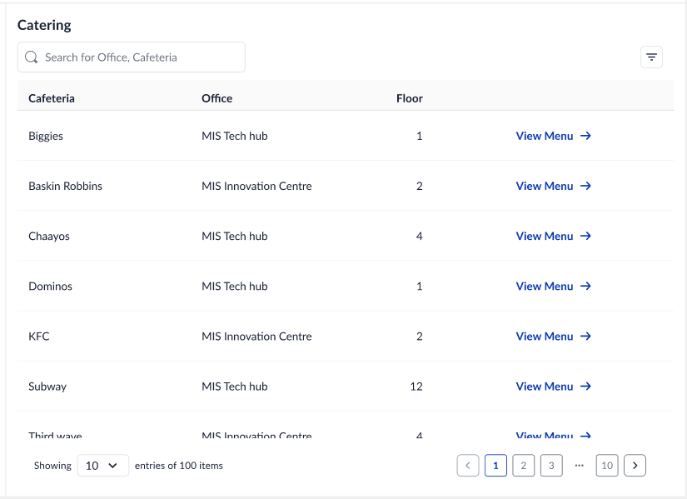
    - When admin clicks on “Manage Details” they will be taken to the management of the cafeteria details for that specific cafeteria and office that they selected for

Use Case 1.1: As a user (admin / catering manager), I aim to add and manage cafeteria items to keep the menu fresh and aligned with changes in cafeteria availability

- Admin selects “Manage Details” against their desired cafeteria and is navigated to the above page which will be considered the singular Menu for that particular Cafeteria
- First Time User Experience:
  - Nothing is setup for the selected cafeteria - no categories or items are added
  - Admin will need to setup the catering by first creating categories
    - Items cannot exist without a category
  - Only if a category is created would the admin be able to add items to the category
  - These three states would be displayed when the admin is setting up the menu for the first time
- Second time user experience:
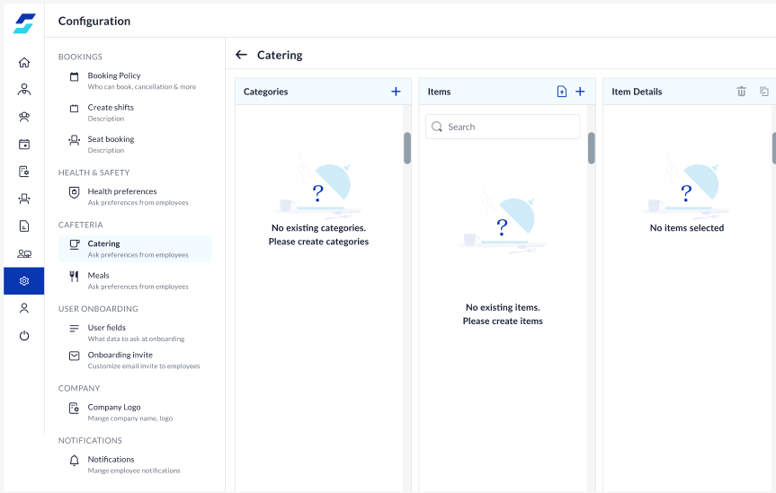
  - If admin has earlier setup the categories and items for the particular cafeteria, when they come to this page they would see the details already populated

Use Case 1.2: As an admin, I want to manage the categories of a cafeteria

- Creating a category
  - Admin would need to select the “+” button in the categories to add a category
  - A modal will pop-up:
    - Modal title: Add Category
    - Text:
      - Category Name → input field, can support alphabetical, numerical and special characters
    - Add button → Creates the Category and adds it to the list of categories in the main page
    - Cancel → does not create the entered category and takes user back to the previous page
    - On first time user experience, the user would come back to the default screen with no categories or items added
- Editing a category
  - Admins can edit a category by hovering over the category, on hover they would see the edit button
  - Upon selecting the edit button, a modal would open allowing the user to edit the category name
    - Modal title: Edit category
    - Category Name: populated with the text present upon edit
    - Cancel → no change to the name of the category
    - Save changes → the changes made to category name get saved
- Deleting a category
  - Admins can delete a category by hoverng over the category, on hover they would see the edit button
  - When they select the “trash” icon, there would be a modal asking them to confirm their changes
    - Modal Title: Delete “Category Name”
    - Text: “Are you sure you want to delete “Category Name. Associated items will also be deleted
    - Cancel→ category doesnt get deleted
    - Delete → deletes the category from the list of categories
      - Items within the category would be deleted along with the category

Adding Items to Categories

Use Case 1.3: As an admin, I want to add items within categories of a cafeteria

- After adding categories, the admin would be able to add items
  - Buttons in items section to be enabled → “+” and bulk upload (bulk upload not handled in V1)
- There are two ways to add items to categories
  - By selecting the category and then the add “+” button in the items section the new item would be added
  - Items can be added only to the selected category, should show the category in selected state when wanted to add an item and when displaying items in the category
- Items within a category to be in A-Z order
- When adding an item, he name of the item would be “New Item”, and the admin must define
  - In creation of the item, the item would not yet be created yet in the backend, only when the user ‘Saves Changes’ would the item be saved
  - Name of the item: input field, alphabetical and numerical inputs allowed
  - Price: the currency synbol would be default based on the currency selected in Manage Premise page
    - Input field, only numerical input allowed
  - Item type: is the item a vegetarian, non-vegetarian or vegan item. Only one classification is allowed
  - Preperation time: input is in numerical form and in hours → converted in backend to minutes as per current logic
    - There is also a tooltip to help the user understand how prep time works, content is mentioned
  - Availability of item i.e the time range for when the item is available in a 12 hour time format
  - Description of the item: input field supporting numerical and alphabetical text
- Default values in items details form when a new item is created:
  - Name: Empty
  - Price: 0
  - Prep time: 0
  - Availability: 0 -24:00
  - Description: empty
  - Item type: select state of dropdown
- On selecting:
  - Cancel → the item is not created at all
  - Save Changes → Item is created and the name of the item reflects as what was given in the form
- Mandatory fields in the Item Details section:
- Name
- Price
- Item type: veg/nonveg/vegan

Use Case 1.3: As an admin, I want to edit items within categories of a cafeteria

- For admin to edit any item, the admin must select the item
- The item form would open up with the details of the selected item, but the Save Changes button would be disabled
  - Unless and until there is a change in any of the details present in the form, the Save Changes button wouldnt be enabled
- When selecting:
  - Cancel → no changes made to the item details
  - Save Changes → Changes made to the item details gets saved

Use Case 1.3: As an admin, I want to delete items within categories of a cafeteria

- Admin would need to hover over the item they wish to delete
- A trash icon would be visible against the item
- Upon selecting the trash icon, a modal would open:
  - Modal title: Delete “Item Name”
  - Text: Would you like to delete “Item Name” all details associated with this item will be deleted.
  - Delete → delete the item and remove from the category and menu
  - Cancel → there would be no changes and the item would remain under that specific category

Use Case 1.3: As an admin, I want to duplicate items within categories of a cafeteria
- Upon selecting “duplicate” icon against an item, the item would get duplicated within that same category
- After duplication, the name of the duplicated item would be of nomenclature “Item Name Copy”.
  - The duplicated item should maintain the same item details (category mapped, description, price, etc)
- For example for the item:
  - Item Name: Fries
  - Category Dropdown Selection: Snacks
  - Price: $ 20
  - Preperatin Time: 24 (hours)
  - Availability: 4:00 PM - 6:00 PM
  - Description: xxx
  - Item type: Veg
- When the above item is duplicated, the duplicated item name should be named“Fries Copy” and items details should be duplicated/a copy of the entry that was duplicated
- In duplication the item would not yet be created yet in the backend, only when the user ‘Saves Changes’ would the duplicated item be saved

Handling the migration of catering configurations for exsisting clients to this UI

On release of this catering configurations to production, all the cafeterias, menu and items that are already present in DB should be migrated and visible here without the Admin having to remap the entire database again

Broken Flow
Use Case:
Use case 1- In case the Category is deleted completely - then, in that case, all future orders should be marked as canceled. Emails need to be handled for the same
Use case 2 - In case the Cafeteria is deleted, all future orders related to the same cafe should be marked as canceled. Emails need to be handled for the same
Use Case 3 - In case any item is deleted from the category - do not take any action. We’ll do in future sprints.
Acceptance:
- It should be applicable for both catering booking and meal booking
- Relevant emails should be sent to the respective recipients

Analytics for Catering:

This section covers the analytics that are needed for analysis of catering bookings. This would be a part of the meeting rooms section

Employee:

Event | Action | Description
Add Catering Request CTA | On click | No of users who are clicking on the catering request
Search | Type of letters and search | Number of users who are using the search option
Total Items |  | Total number of menu items added
Place Order | On click | Total number of users who complete the catering selection option
Confirm | On click | Total number of users who complete the booking (May be present in the meeting room booking already, please check)
Add food items CTA | On click | Total number of users who proceed to select the food items
New Delivery CTA | On click | Total number of users who would click on the new delivery to add a new delivery order OR the number of catering requests that have more than 1 order

Catering Email:

The following emails would be related to catering:
- Email for set of configured users
- Email for employee (V2)
- Email for set of user groups (V3)

Email for set of configured users:

- The email is sent to a set of users in the organization on creation of catering request (this was built already)
- The email that is sent to set of users in the organization needs to be updated to a similar template as that of the email sent to the organizer
- Provide option to send catering emails (the one sent to catering managers) to a set of users
- The email to be sent would be configured at office level or cafeteria level. @Neha Sharma to come back on feasibility
- Remove the previous code of sending catering emails at user group level when privilege is enabled
  - This applies to all emails sent to catering managers
  - Organizer emails should not be impacted

Email for employee (organizer):

The employee who created the catering booking should receive the details in an email:

Figma: https://www.figma.com/file/WeJg9vdrUcWEPjcIWLr3uz/Catering-Dashboard?node-id=688%3A261561&t=H5Ob534i0j9opSbi-4

Solution:
- The email is sent to the employee after completion of the meeting room booking if catering is present in the booking
- Subject of the Email: Catering Requested for Meeting: XXXXX
  - XXXX → is the meeting ID
- From ID: noreply@workinsync.com
- The email consists of the meeting ID and order IDs and table view:
  - Meeting ID: Refers to the meeting that the user has created
  - Date and time: The requested date and time of the meeting
  - Order ID: Each order and its details are visible one after the other in the email
    - Each order has its own requested date and time. In case of add / edit of an order / meeting, this can be captured
  - All the special requests specific to the catering order would be present below the table of the individual order

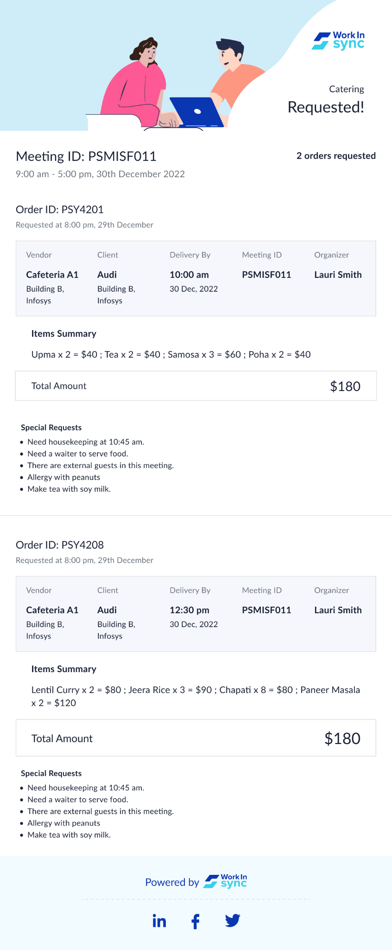

Catering Email should be sent to set of stakeholders

Problem Statement:
In organizations like Richemont - catering managers use a shared email ID for the catering emails, but will use their individual login to see orders on the catering dashboard.
Solution:
- Provide option to send catering emails (the one sent to catering managers) to a set of users
- The email to be sent would be configured at office level or cafeteria level. @Neha Sharma to come back on feasibility
- Remove the previous code of sending catering emails at user group level when privilege is enabled
- This applies to all emails sent to catering managers
- Organizer emails should not be impacted

Change in Catering Templates

Problem Statement:
As the email templates are heavy on images, they often don’t load properly or look broken when loaded on Outlook or Google. To improve user experience, we’ll need to revamp the templates.
Solution:
Revamp the templates for catering
- Images, colors, footers to be changed based on template
- Things to be added newly:
  - Meeting title
  - Cost center
  - Organizer - add email address along with name
  - Number of participants
- Emails to be revamped:
  - Catering Requested
  - Catering Accepted
  - Catering Rejected
  - Catering Delivered
  - Catering Updated
Figma: https://www.figma.com/design/WeJg9vdrUcWEPjcIWLr3uz/Catering-Dashboard?node-id=688-261561&t=KctMsArnVKn8LigP-4

Email for set of user groups: (V-3 scope)

Reports:

